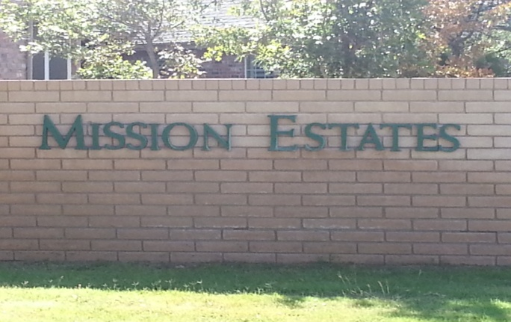 NEWSLETTER April 2015
MISSION ESTATES PROPERTY OWNERS’ ASSOCIATION
From the Board of Directors
The Board of Directors are charged with upholding the rules set forth in the Covenants, Conditions, and Restrictions (CCR). Any complaint received must be addressed according to the guidelines provided in the CCR. A large part of their responsibilities is overseeing all dues that are collected and expenditures for the Association. These expenditures include grounds maintenance, water bills, electric bills, sprinkler repairs, fertilization, legal fees, and office expenses to mail statements and notices. The Board members are all volunteers and take their jobs seriously.

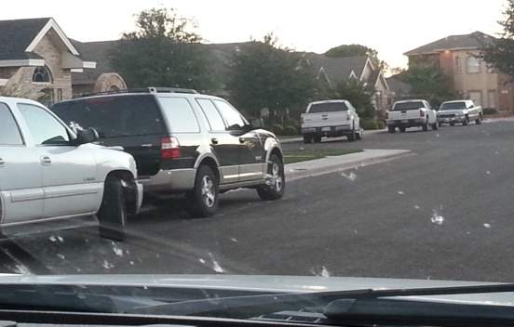

The most common question the Board receives:
Can cars be parked in the street?
Reference: Article VI, Section 1. Paragraph F.
Except as otherwise provided herein, no trailer, mobile home, boat, recreational vehicle, truck larger than ½ ton, or vehicle other than passenger automobiles shall be permitted to park over night on any streets located within The Properties.

What about motor homes or trailers?
Reference: Article VI, Section 1. Paragraph G.
No trailer, mobile home, boat, recreational vehicle, truck larger than ½ ton, or vehicle other than passenger automobiles shall be parked, maintained, stored or kept on a Lot or Tract unless housed completely within an enclosed structure approved by the Review Board. Approval of the enclosed structure shall be limited to those designs using materials compatible with the main structure on the Lot or Tract and which, to the greatest extent possible, conceal the boat, trailer or vehicle from view from any street, golf course or other public areas.

The 11th Filing update:

When the 11th filing was developed, due to an oversight by the developer, some important filing steps were neglected. As a result there is some confusion surrounding the status of the lots in the 11th filing. Because of this confusion and in order to protect the owners of homes and lots in the 11th filing, the MEPOA Board is requesting that you sign and have notarized the “Supplemental Declaration of Covenants and Restrictions for Mission Estates 11th Filing” that was previously mailed and return it to the Association. Should you need a copy please contact us and one will be provided. By signing the Declaration, you are agreeing that you understand that your home and/or lot are in the 11th filing of Mission Estates and that you understand that you are obligated to comply with the Covenants and Restrictions of MEOPA and that you are protected by those same Covenants and Restrictions. This Declaration will not affect the dues you pay to the Association nor will it change the valuable benefits that you receive from being a Mission Estates homeowner.
We appreciate your assistance in resolving this matter and appreciate the prompt return of the signed and notarized Declaration. Most banks, credit unions and insurance agents can notarize the Declaration. Additionally, the business office at Odessa Country Club can notarize the Declaration during normal business hours Tuesday through Friday, 8-5.
All property on San Saba, San Saba Ct, San Pedro, or San Marino is included in the 11th Filing. If you need a copy of the Declaration please contact the Association at www.missionestates.net and one will be provided.

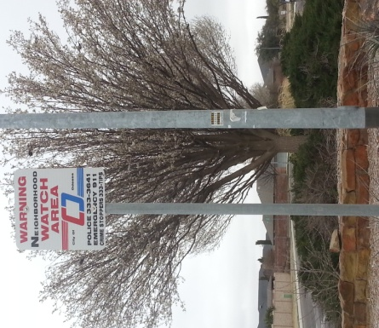

Neighborhood Watch Meeting
The Board of Directors scheduled a meeting of the HOA for February 24th with the City of Odessa Police force to explain how to establish a Neighborhood Watch program. Unfortunately, the OPD representative that attended the meeting was not briefed accordingly. The OPD did have three officers who patrol Mission Estates to attend the meeting to provide information. Sgt. Thompson said they are charged with patrolling east of Grandview to University and 52nd Street and Mission Estates. It is a large area, but they do patrol through the Mission Estates at least once per shift. Mission Estates is not considered to be a high crime area, and most crimes are ones of opportunity. The most common violation they encounter is burglary of vehicles. The following safety tips were presented:

Vehicles

Park in your garage if possible
Lock your vehicle
Do not leave valuables visible in your vehicle
Activate alarms

Homes

Use your alarm system and be sure it is registered with OPD
Install security cameras
Install motion lights in dark areas
Report suspicious activity
Advise your neighbors when you are travelling

If you call 911 let the dispatcher know you live in Mission Estates. A cell number is does not have location associated with it and there is a major delay from Midland to Ector County. You can also dial direct to the OPD at 432-333-3641. All calls require a response.

An armed security system will generate calls to the homeowner and the police when registered with OPD. An officer will respond to an alarm and, by law must clear the residence. They will go in if the door is open to secure your home. A typical response time is 20 to 30 minutes once the alarm is received. If you have a security camera, the OPD has equipment that can enhance your video surveillance to better identify a person or vehicle. He encouraged homeowners to become familiar with their cameras to be sure how long recordings are held and how to rewind and view for activity.

The Board of Directors will continue to work on the Neighborhood Watch Program, and information will be posted on the Mission Estates website when available.

If you would like to file a report with the Odessa Police Department online the website is www.odessapd.com.

The Midland 911 District number is 684-9911. Their purpose is to assign physical addresses to homes in Midland County. You can contact them to verify your address is registered in their system.

Note from the Landscape Committee…

Mother Nature has been very active this year. The recent ice storm caused several tree limbs to break. If you notice broken limbs in need of attention please notify a Board member. The Board is working on changes in the common areas in the coming months.

From the Architectural Review Board….
Just a reminder, all plans for modifications or new construction must be presented to the ARB prior to beginning the project. The City of Odessa requires plans be approved by the ARB before issuing a permit. You may contact Greg Eddings 432-288-5889.

The Association does not have jurisdiction over the following:

- Vehicles being parked on curbs or facing the wrong direction on the street – report to the Odessa Police Department at 333-3641 (non emergency) or 911 (emergency).
- Vandalism and / or speeding – report to the Odessa Police Department at 333-3641 (non-emergency) or 911 (emergency).
- Street lights in need of repair – report to the City of Odessa at 335-3242.
- Alley or street repairs – report to the City of Odessa at 335-3241.
- Problems with animals – report to Animal Control at 368-3526.
- In the spirit of being a good neighbor, please secure any loose or large trash in the alleyways.

JUST A NOTE

Board meetings are held once a month. If you would like to attend, contact a Board member to be informed of the time, place, and be placed on the agenda.

We would like to compile email addresses for all homeowners. This would allow us to reduce the cost of postage and printing for all billing and notices sent to our homeowners. The emails would be used strictly for the Association and not shared with any entities. You can send us your email at our website contact link at www.missionestates.net to frances@missionestates.net

If you did not receive or have misplaced your copy of the Covenants and Restrictions, contact Frances Seely (Administrative Assistant) at 381-6327 or francesandronni@gmail.com to receive a copy for a fee of $10.00.

2014-2015 BOARD OF DIRECTORS

Jim Brown Jim Stuart Michael Gauthe LaDoyce Lambert
Phil Fouche Kurt Verlei Ryan Edgmon Greg Eddings

Contact a director at our website link at www.missionestates.net or email them at boardofdirectors@missionestates.net

